Name =

Abubaker Attique

Roll no =

P20-0560

Section =

5-A

Lab 8

**INSTALLATION PROCESS:**

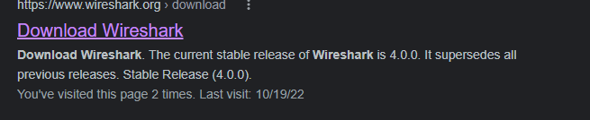

**Install this setup :**

**After installation**

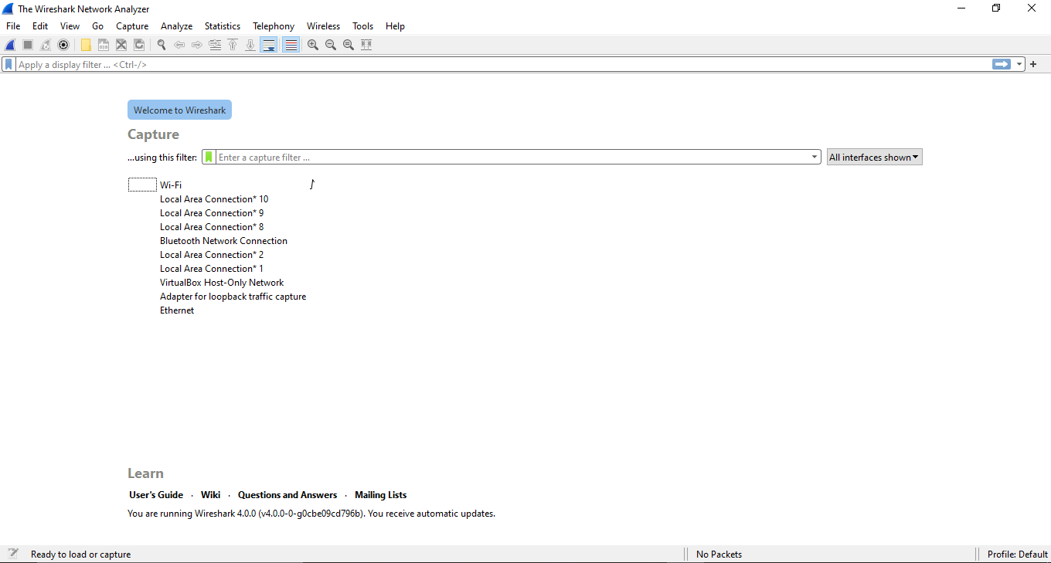

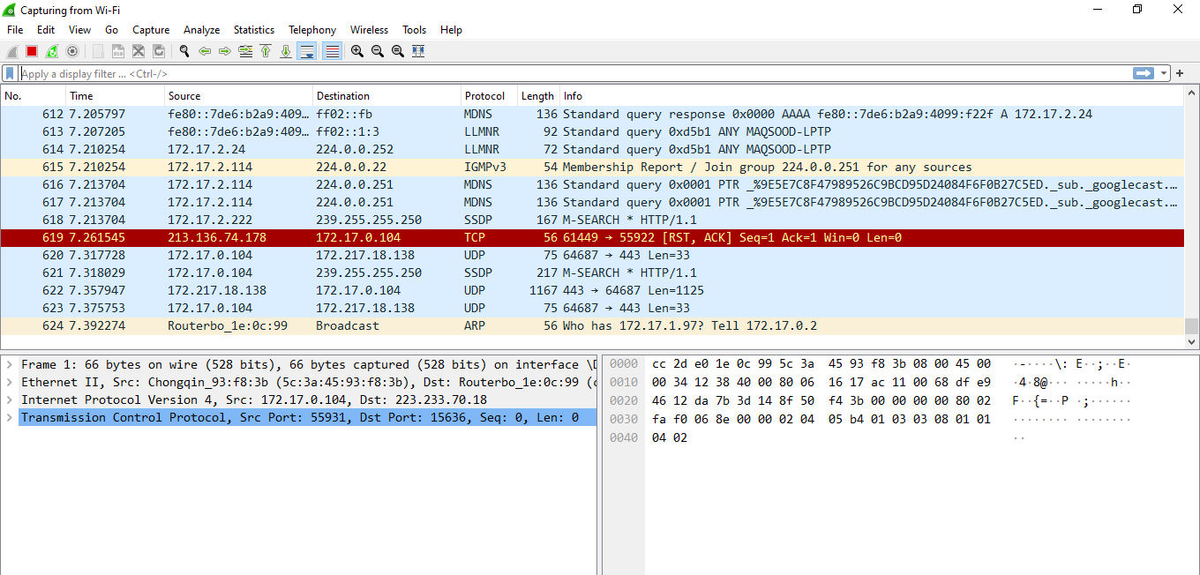

**Task: By looking at the information in the HTTP GET and response messages, answer the following questions**

1. **Is your browser running HTTP version 1.0, 1.1, or 2?**

**Answer :**

Browser is running on HTTP version 1.1.

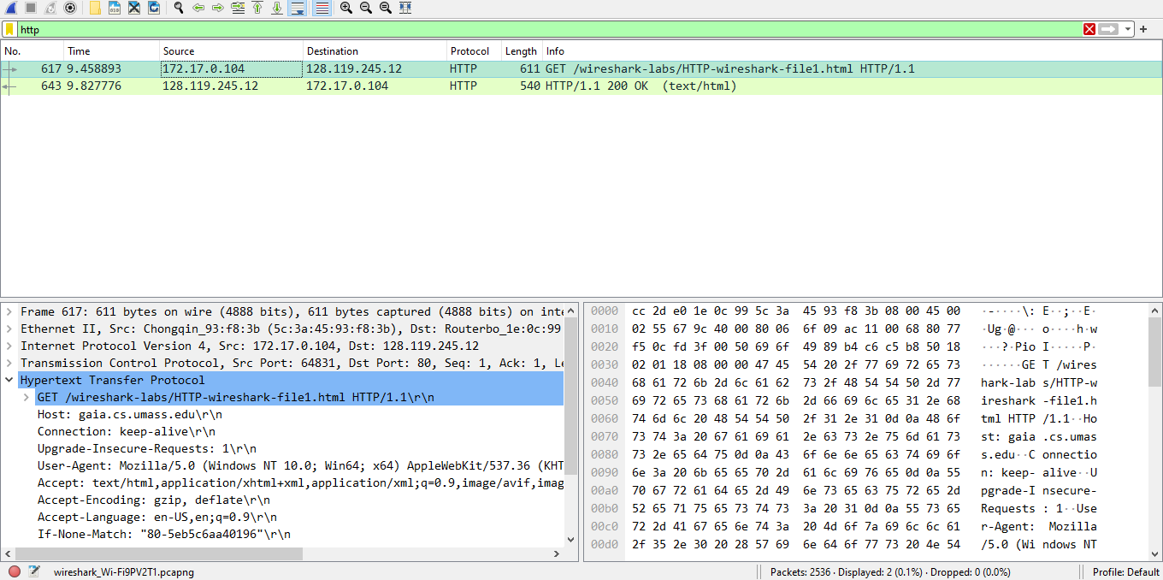

1. **What version of HTTP is the server running?**

**Answer :**

Server is running on Http 1.1.

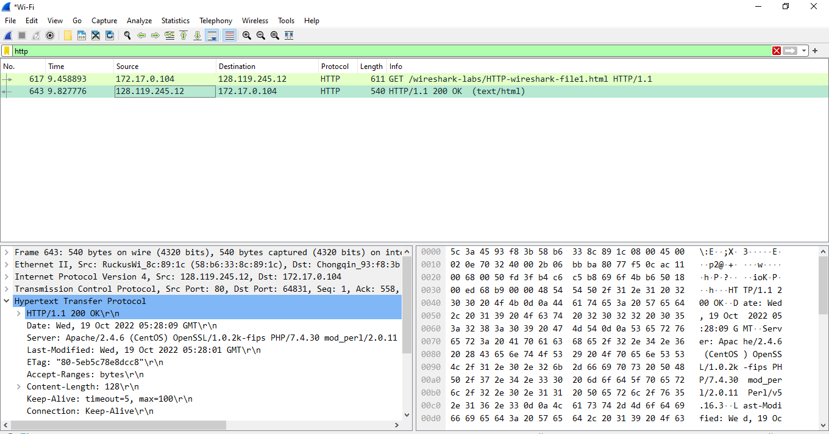

1. **What languages (if any) does your browser indicate that it can accept to the server?**

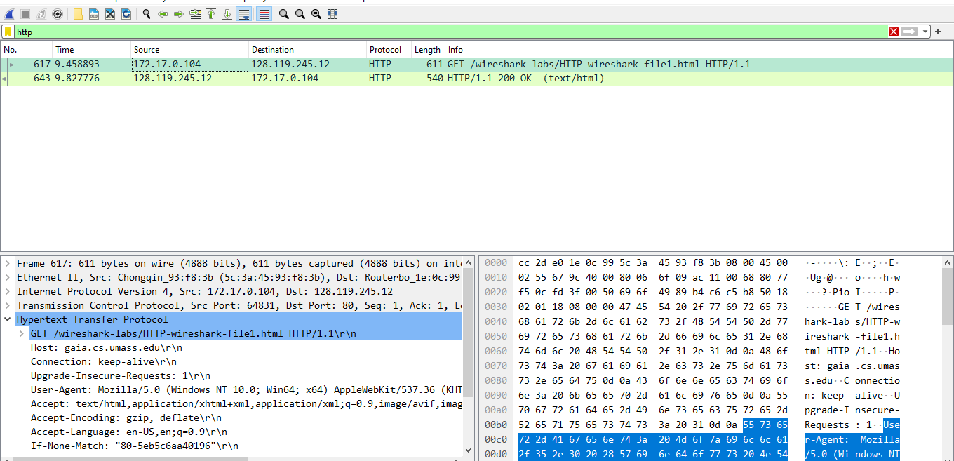

**4.What is the IP address of your computer? What is the IP address of the gaia.cs.umass.edu server?**

**Answer :** To know about the ip address of our computer will we open our command promt and write ipconfig……from there we will know about the ip address of the computer.

**Ip of my computer :**

IPV4 Address = 172.17.0.104

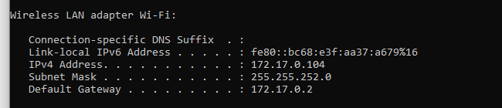

**IP address of the gaia.cs.umass.edu server**

In the wireshark here we can see the ip addresss

**172.17.0.104**



**5.What is the status code returned from the server to your browser?**

**Answer :**

The status code returned from the server to browser is 200 OK.



**6.When was the HTML file that you are retrieving last modified at the server?**

**Answer :**

Here in the Wireshark we can see the last modify as shown in the pic below.

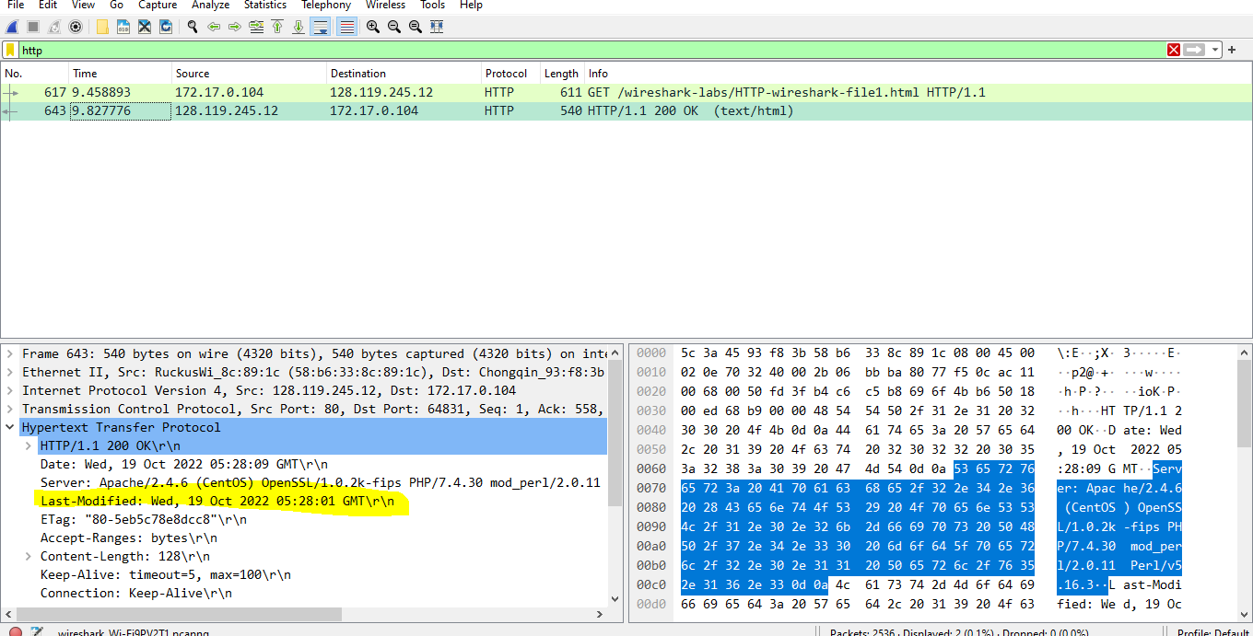

**7.** **How many bytes of content are being returned to your browser?**

**Answer :**

In this we can see the file size in bits

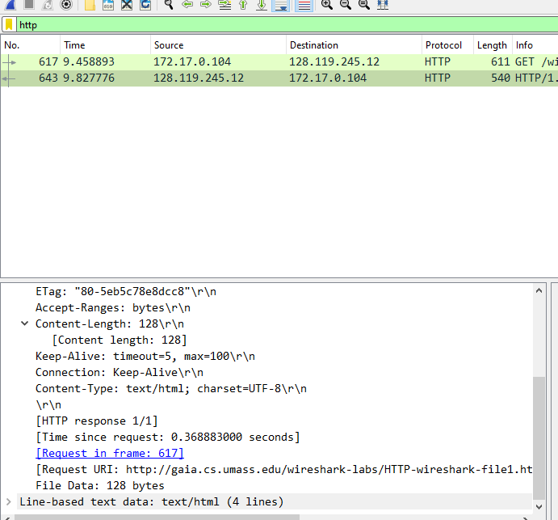

**8.** **By inspecting the raw data in the packet content window, do you see any headers within the data that are not displayed in the packet-listing window? If so, name one**

**Answer :**

No there is no header within the data that are not displayed in the packet-listing window.

**Task 2: Answer the following questions:**

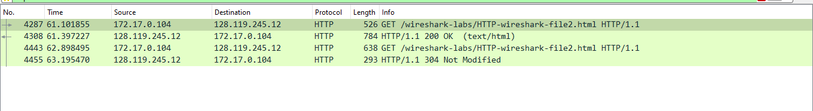

1. **Inspect the contents of the first HTTP GET request from your browser to the server. Do you see an “IF-MODIFIED-SINCE” line in the HTTP GET?**

**Answer :**

There is no “IF-MODIFIED-SINCE” in the first HTTP GET request because the request for the server is for first time.

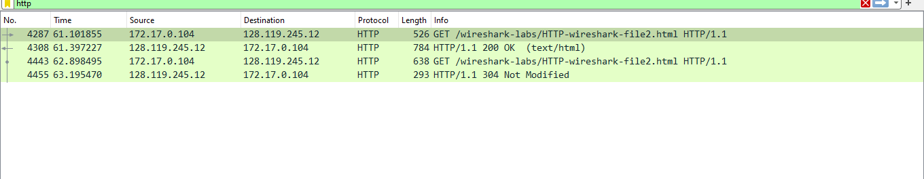

**2.Inspect the contents of the server response. Did the server explicitly return the contents of the file? How can you tell?**

**Answer :**

When we inspect the contents of the server response, the contents of the file were returned by the server explicity.But in the second respose it did not give the explicity result.

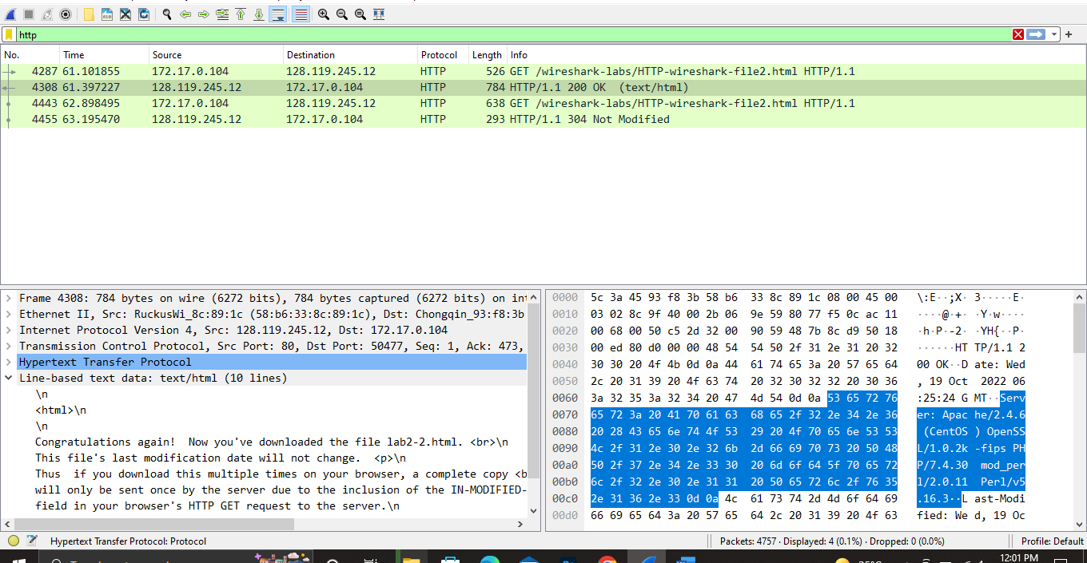

This give the result explicity.

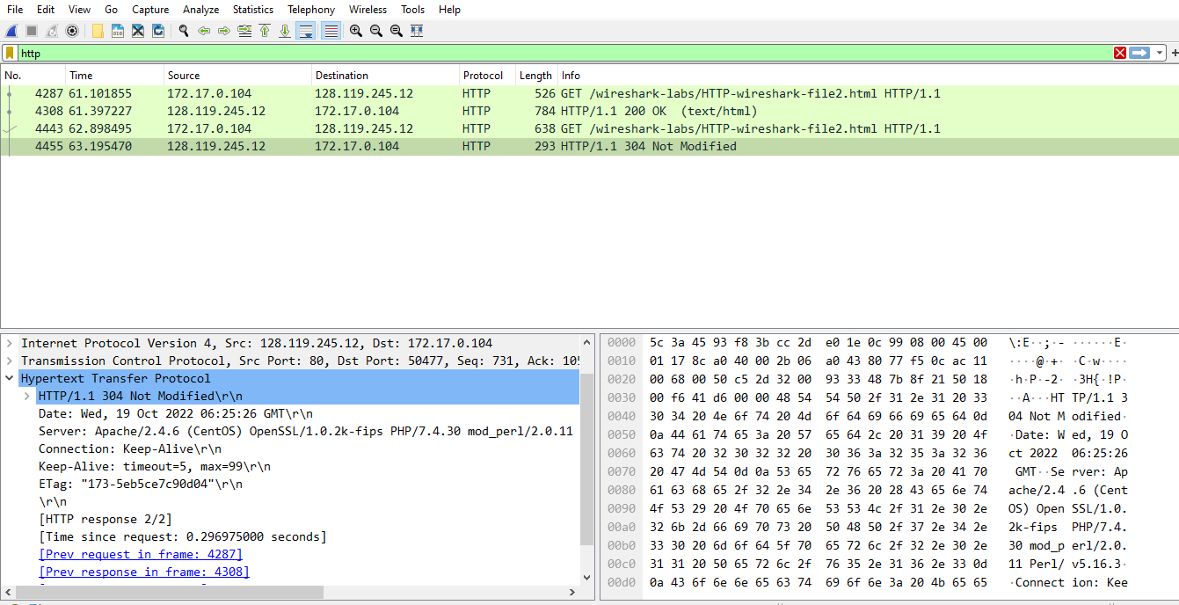

This did not give the result explicity.

**3.Now inspect the contents of the second HTTP GET request from your browser to the server. Do you see an “IF-MODIFIED-SINCE:” line in the HTTP GET6 ? If so, what information follows the “IF-MODIFIED-SINCE:” header?**

**Answer :** After inspection the content of HTTP GET request from your browswer to the server , we see an “IF-MOBIFIED-SINCE” , we get the date , time, day this is because we refresh the page.

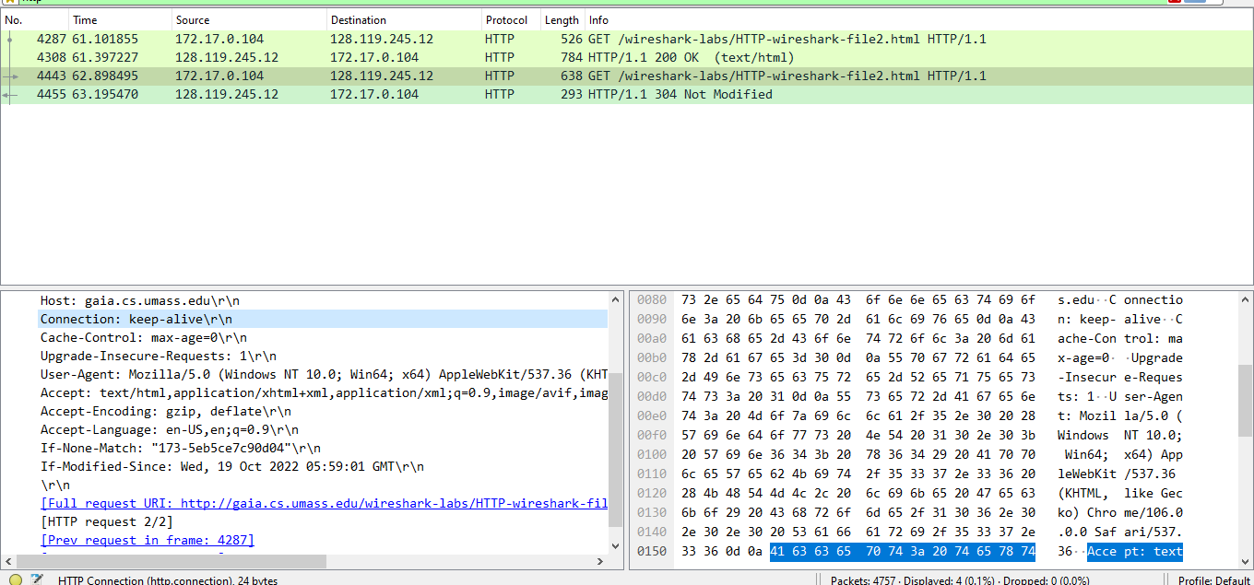

**Q4: What is the HTTP status code and phrase returned from the server in response to this second HTTP GET? Did the server explicitly return the contents of the file? Explain.**

**Answer :** 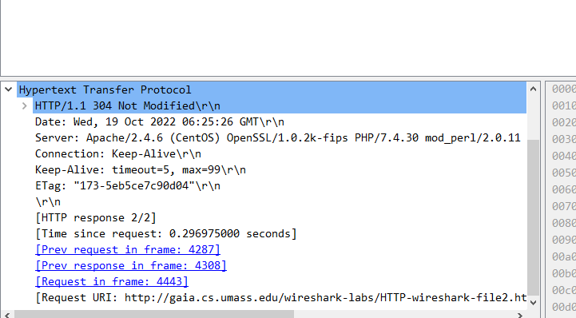

It is NOT MODIFIED because when the request is done for the first time it will from the server when we again refresh the page this time it will not give from server this time it will be from cache.